Experiment-37

Write a LEX program to find the length of the longest word. Code:
%{
#include <stdio.h> #include <string.h>
int maxlen=0; char longest[256]="";
%}
%%
[a-zA-Z]+ {
if(yyleng > maxlen){ maxlen = yyleng; strncpy(longest, yytext, sizeof(longest)-1); longest[sizeof(longest)-1]=0; }
}
.|\n ;
%%
int main(){ yylex(); printf("Longest Word: %s\nLength: %d\n", longest, maxlen); return 0; } int yywrap(){ return 1; }

Output:
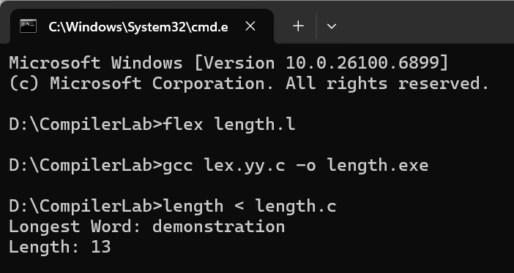

Experiment-38
Write a LEX program to count the frequency of the given word in a given sentence. Code:
%{
#include <stdio.h> #include <string.h> char target[128]; int count=0;
%}
%%
[a-zA-Z]+ {
if(strcmp(yytext, target)==0) count++;
}
.|\n ;
%%
int main(){
printf("Enter the word to search: "); scanf("%127s", target);
getchar(); /* consume newline */ printf("Enter text (Ctrl+Z to end):\n"); yylex();
printf("Frequency of '%s': %d\n", target, count); return 0;
}
int yywrap(){ return 1; }

Output:
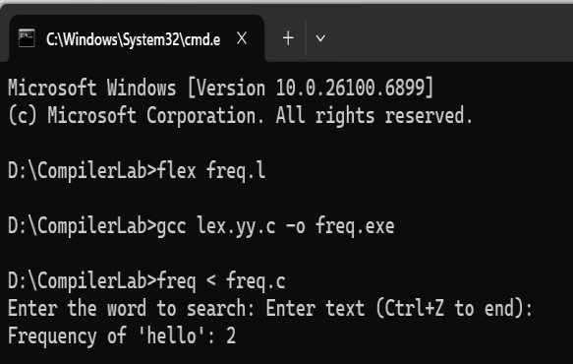

Experiment-39

Write a LEX code to replace a word with another word in a file. Code:
%{
#include <stdio.h> #include <string.h>
char oldw[128], neww[128];
%}
%%
[a-zA-Z]+ {
if(strcmp(yytext, oldw)==0) printf("%s", neww); else printf("%s", yytext);
}
[ \t\n]+ { printf("%s", yytext); }
. { printf("%s", yytext); }
%%
int main(){
printf("Enter word to replace: "); scanf("%127s", oldw); printf("Enter new word: "); scanf("%127s", neww); getchar();
printf("Enter text (Ctrl+Z to end):\n"); yylex();
return 0;

}
int yywrap(){ return 1; }

Output:
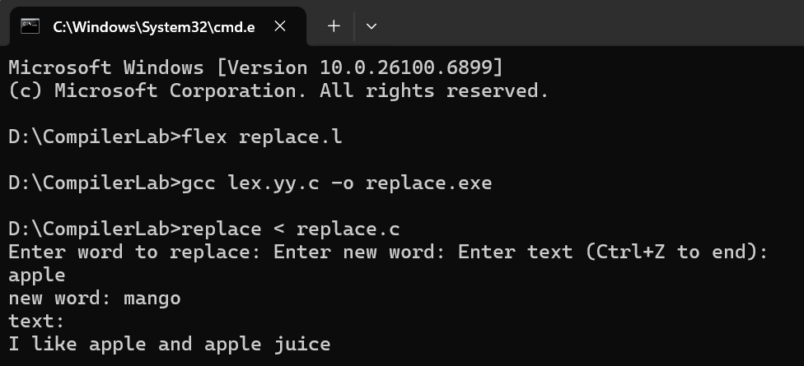

Experiment-40
Write a LEX program to recognize a word and relational operator. Code:
%{
#include <stdio.h>
%}
REL (<=|>=|==|!=|<|>)
WORD [a-zA-Z_][a-zA-Z0-9_]*
%%
{REL} { printf("Relational Operator: %s\n", yytext); }
{WORD} { printf("Word: %s\n", yytext); }
[0-9]+ { printf("Number: %s\n", yytext); }
.|\n ;
%%
int main(){ yylex(); return 0; } int yywrap(){ return 1;
Output:
